**Problem 1 : Evil Number**

Input : 9

Explanation : Square of 9 is 81

Sum of digits of a square is 9 (which is equal to input) So the number is a Evil number

Output : Evil Number

**Problem 2 : Power Number**

A Number is said to be a Power Number if the sum of all the digits is equal to the product of all digits

Input : 132

Explanation :

Sum = 1 + 3 + 2 = 6

Product = 1 * 3 * 2 = 6

Here Sum and Product are same so the number is a Power Number

**Problem 3 : Automatic Number**

A number is called Automatic Number if and only if its square ends in the same digits as the number itself

Input : 76

Explanation :

76 * 76 = 5776

Output : Automatic Number

**Evil Number Example**

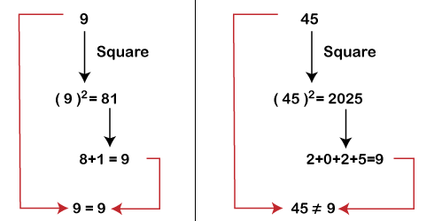

**Power Number Example :**

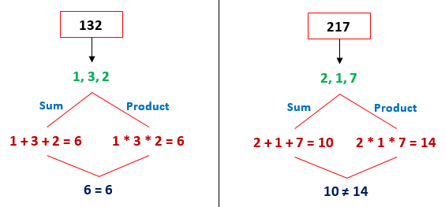

**Automatic Number**

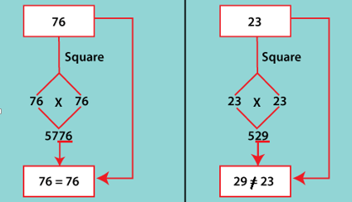

**Problem 4 :**

**Problem 4 : Technology Number**

1. Read or initialize a number (**num**).
2. Find the number of digits of the given number (**num**).
3. Split the given number into two parts (**num1** and **num2**), equally. Note that each part must contain an equal number of digits.
4. Sum up the numbers (**num1+num2**) and store the result in a variable
5. Find the square of the variable **sum** and store it in a variable **square**.
6. Compare the **num** with the **square of the sum** if they are equal print **Technology Number,** else print **Not a Technology Number.**

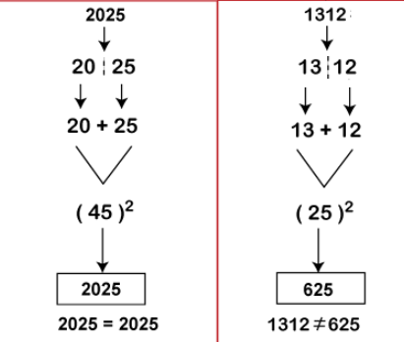

**Problem 5 : Busy Number**

1. We first take a number.
2. We then find the last digit of the number and check whether it is equals to 7 or not. If it equals 7, print "the number is a Busy" number.
3. We then find the remainder of the number with 7. If the remainder equal to 0, print "the number is a Busy number".
4. Else print "number is not a busy number".

**Question 1:**

1. Write a Java Program to check whether a number is prime or not

Example : **3**

Output : Prime Number

1. Write a Java Program to find the the number of prime numbers between 111 to 511.
2. Write a java program to find whether a year is leap year or not.

START

Step 1 → Take integer variable year

Step 2 → Assign value to the variable

Step 3 → Check if year is divisible by 4 but not 100, DISPLAY "leap year"

Step 4 → Check if year is divisible by 400, DISPLAY "leap year"

Step 5 → Otherwise, DISPLAY "not leap year"

STOP

Input : 1900

Output : NOT LEAP YEAR

1. Write a Java Program to print the Fibonacci series from up to 10 terms.

Each Number is the sum of previous 2 numbers

Output :

0 1 1 2 3 5 8 13 21 34

**Problem 3 : Print the following patterns**

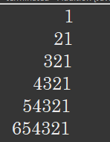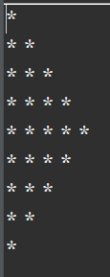

1. Which component is used to compile, debug and execute java program?  
a) JVM  
b) JDK  
c) JIT  
d) JRE

**Output__________________________**

2. Which component is responsible for converting bytecode into machine specific code?  
a) JVM  
b) JDK  
c) JIT  
d) JRE

**Output__________________________**

3.Which component is responsible to run java program?  
a) JVM  
b) JDK  
c) JIT  
d) JRE

**Output__________________________**

4.Which of the following option leads to the portability and security of Java?

a. Bytecode is executed by JVM

1. The applet makes the Java code secure and portable
2. Use of exception handling
3. Dynamic binding between objects

**Output_________________________**

5. _____ is used to find and fix bugs in the Java programs.

a. JVM

b. JRE

c. JDK

d. JDB

**Output__________________________**

6. What is an object in Java

**A.**static reference

**B.**template or blueprint

**C.**instance of class

**D.**None of above

**Output__________________________**

7. What is a class in java

**A.**static reference

**B.**template or blueprint

**C.**instance of class

**D.**None of above

**Output__________________________**

8. A class can have

**A.**Fields and Methods

**B.**Constructors and Blocks

**C.**Nested class and interface

**D.**All of above

**Output__________________________**

**9.** Using __________ key word , a Object will be created

A. int

B. new

C. float

D.String

**Output__________________________**

10. An Object can be created of type Room and assign its address to variable r1 as

a. r1 = new Room();

b. r1= Room() new;

c. r1= Class Room();

d. None

**Output_________________________**